## --------------------------------------------------------------------------------------------------------------------------------------

## CS5590 Web Mobile – Lab 3 –Report

## #26, Avni Mehta

## --------------------------------------------------------------------------------------------------------------------------------------

Task 1 Objective:

Create an application that display the desired videos based on the keywords entered by the user in the search.

Code:

The HTML page contains the input text field and search button. I have reused a lot from my previous code of news application.

The JavaScript contains the main logic to call YouTube API, pass parameters and get results.

Here, I am calling the API, getting top 10 results, setting the results into the video array, and displaying proper error messages.

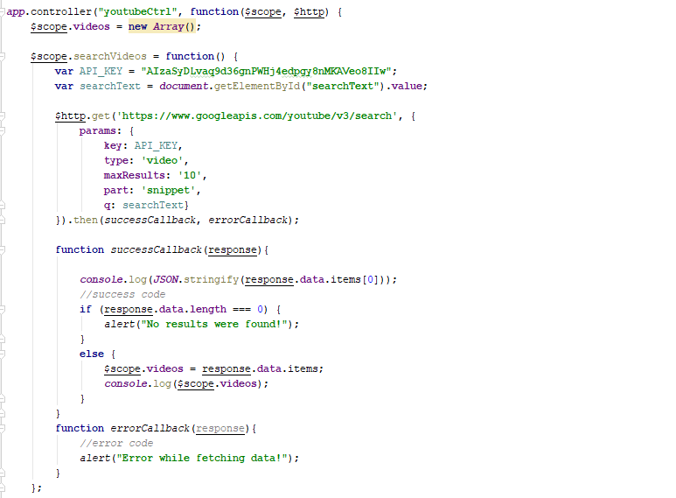

Output:

When the page loads.

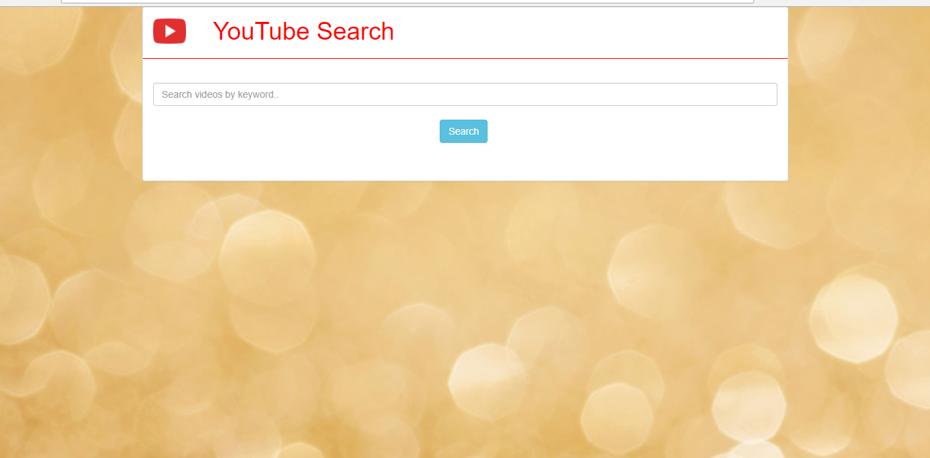

When the user hits Search button without entering any keywords, the API will fetch Top 10 videos trending that time.

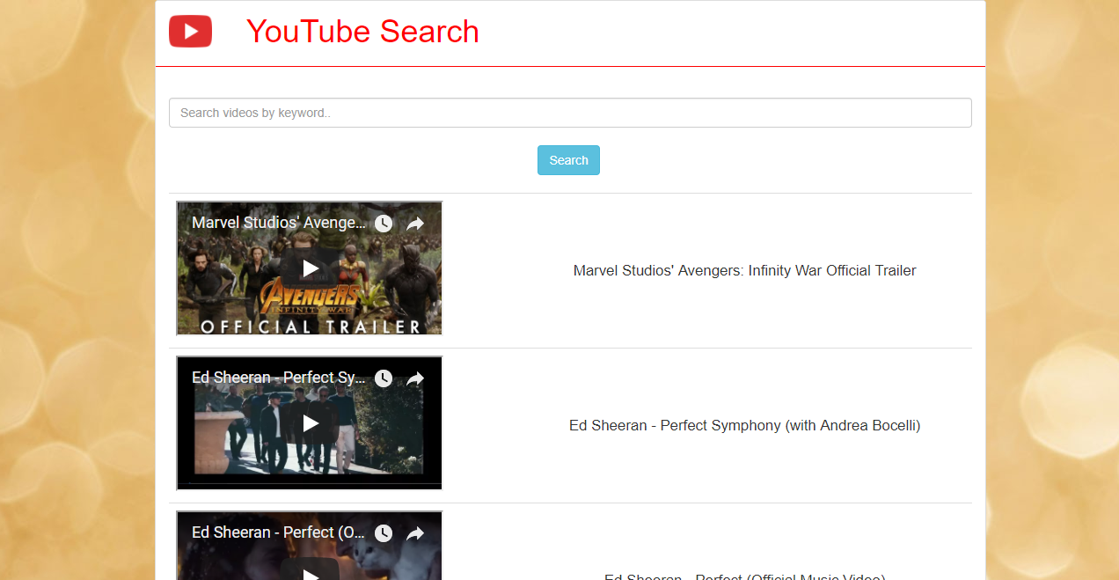

Upon searching by keywords, top 10 videos will be embedded along with their titles.

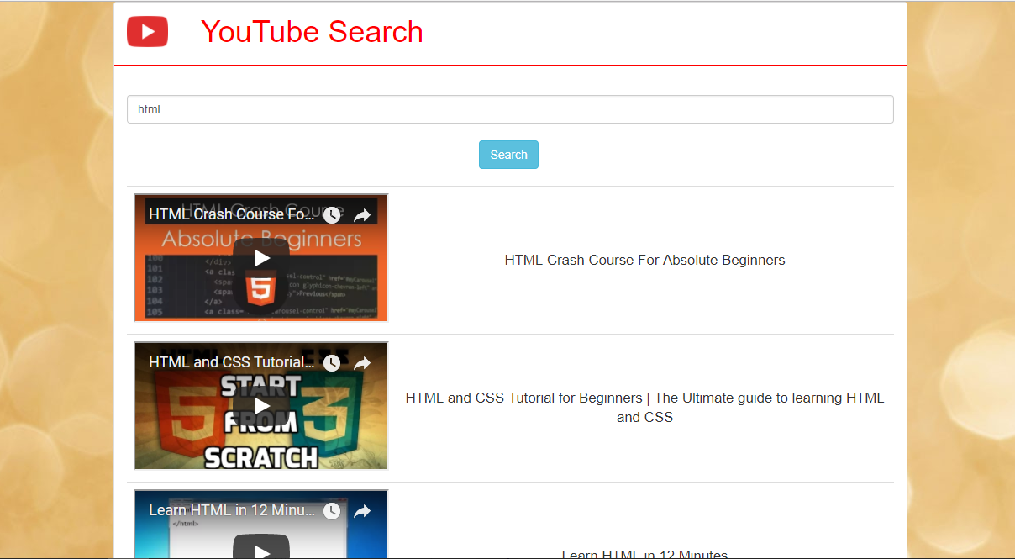

When the user plays the embedded videos,

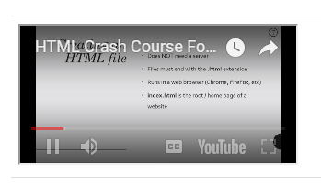

Task 2 Objective:

Get twitter friends list using Twitter API and visualize them through D3.js.

Code:

The html page displays the friends and friends-of-friends in form of a tree. The code has been reused from the previous In-Class Exercise of d3.js

The CSS contains code for styling and displaying the elements.

The JavaScript contains the API call, where screen_name and #records is passed as parameter and the resulting array is stored into a directory.

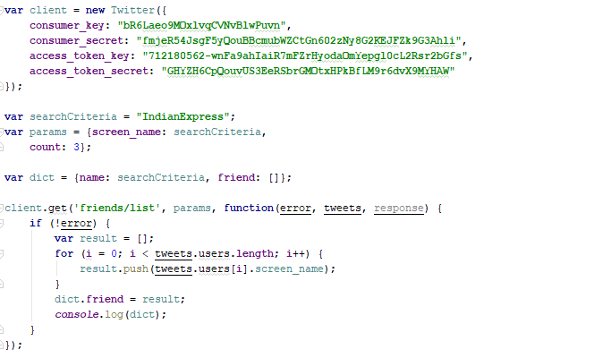

The JSON file created is:

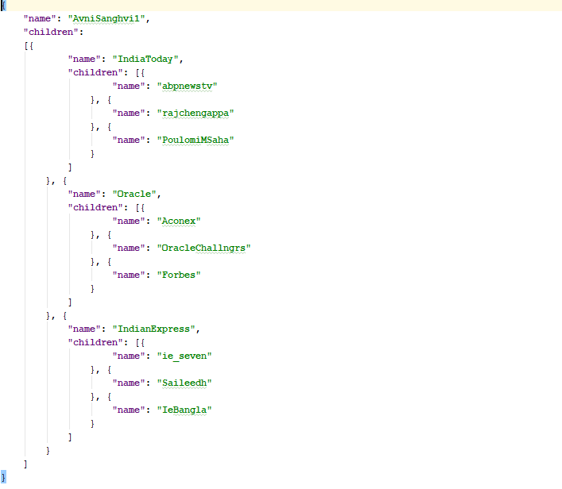

Output:

The output is in the form of a tree.

The Root level is the name that is queried.

The first level are the friends of the root level.

The second level are the friends of friends.

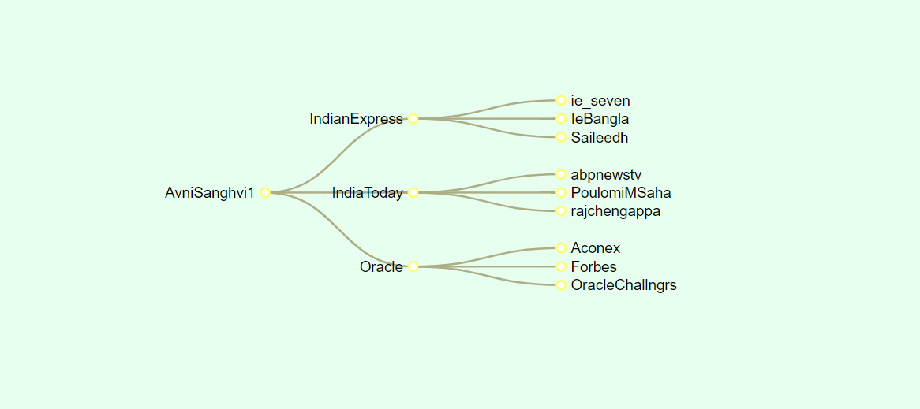

We can drag and drop the items in the tree

